# 线性回归

## 导入实验所需包

import numpy as np  
import pandas as pd  
from sklearn.model_selection import train_test_split  
from sklearn.linear_model import LinearRegression #线性回归  
from sklearn.linear_model import LogisticRegression #逻辑回归  
from sklearn.preprocessing import StandardScaler  
from sklearn.metrics import mean_squared_error

## 定义模型

# 定义模型  
def linear_model(X_train, X_test, y_train):  
 # 线性回归  
 lr = LinearRegression()  
 lr.fit(X_train, y_train)  
 y_pred = lr.predict(X_test)  
 return y_pred

## 数据处理

# 全部特征  
def dataProcess_full():  
 # 加载 dataset/housing-data.csv  
 df = pd.read_csv('dataset/housing-data.csv')  
 # 数据处理  
 # 平均值填充  
 df = df.fillna(df.mean())  
 X = df.iloc[:, :-1]  
 y = df.iloc[:, -1]  
 X_train, X_test, y_train, y_test = train_test_split(X, y, test_size=0.2, random_state=0)  
 # 标准化  
 sc = StandardScaler()  
 X_train = sc.fit_transform(X_train)  
 X_test = sc.transform(X_test)  
 return X_train, X_test, y_train, y_test  
# 部分特征  
def dataProcess_part():  
 # 加载 dataset/housing-data.csv  
 df = pd.read_csv('dataset/housing-data.csv')  
 # 数据处理  
 # 平均值填充  
 df = df.fillna(df.mean())  
 X = df.iloc[:, [0, 1, 2, 3, 4, 5]]  
 y = df.iloc[:, -1]  
 X_train, X_test, y_train, y_test = train_test_split(X, y, test_size=0.2, random_state=0)  
 # 标准化  
 sc = StandardScaler()  
 X_train = sc.fit_transform(X_train)  
 X_test = sc.transform(X_test)  
 return X_train, X_test, y_train, y_test

## 主函数

# 设置显示中文字体  
from pylab import mpl  
mpl.rcParams["font.sans-serif"] = ["SimHei"]  
  
# 全部特征  
X_train, X_test, y_train, y_test = dataProcess_full()  
# 将y_test转换为一维数组  
y_test = np.array(y_test).reshape(-1, 1)  
y_pred = linear_model(X_train, X_test, y_train)  
# 可视化  
from matplotlib import pyplot as plt  
plt.title('线性回归全部特征')  
plt.plot(y_test, label='y_test')  
plt.plot(y_pred, label='y_pred')  
plt.legend()  
plt.show()  
print('全部特征MSE:', mean_squared_error(y_test, y_pred))  
# 部分特征  
X_train, X_test, y_train, y_test = dataProcess_part()  
y_test = np.array(y_test).reshape(-1, 1)  
y_pred = linear_model(X_train, X_test, y_train)  
# 可视化  
plt.title('线性回归部分特征')  
plt.plot(y_test, label='y_test')  
plt.plot(y_pred, label='y_pred')  
plt.legend()  
plt.show()  
print('部分特征MSE:', mean_squared_error(y_test, y_pred))

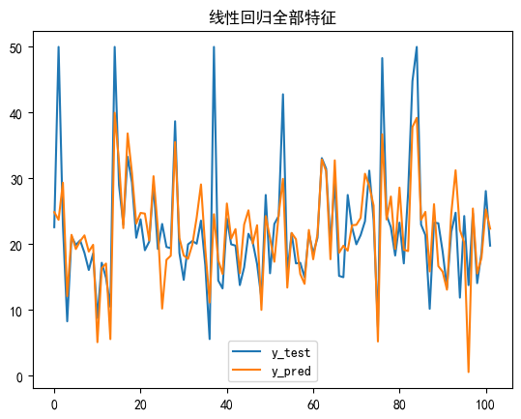

全部特征MSE: 33.448979997676496

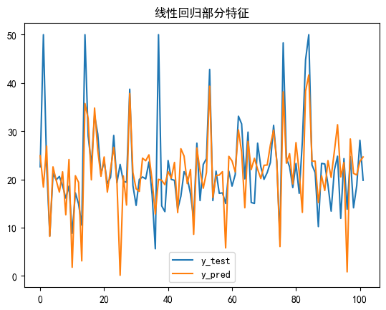

部分特征MSE: 47.24194082350583

# 逻辑回归

## 导入实验所需包

import numpy as np  
import pandas as pd  
from sklearn.model_selection import train_test_split  
from sklearn.linear_model import LinearRegression #线性回归  
from sklearn.linear_model import LogisticRegression #逻辑回归  
from sklearn.preprocessing import StandardScaler  
from sklearn.metrics import mean_squared_error

## 定义模型

def logistic_model(X_train, X_test, y_train):  
 # 逻辑回归  
 lr = LogisticRegression()  
 lr.fit(X_train, y_train)  
 y_pred = lr.predict(X_test)  
 return y_pred

## 数据处理

# 数据处理  
# 全部特征  
def dataProcess_full():  
 path = 'dataset/breast-cancer-wisconsin.data'  
 df = pd.read_csv(path, header=None)  
 # 0填充'?'  
 df = df.replace('?', 0)  
 # 将所有数据转换为int类型  
 df = df.astype(int)  
 # 特征值  
 X = df.iloc[:, 1:-1]  
 # 目标值  
 y = df.iloc[:, -1]  
 # 划分数据集  
 X_train, X_test, y_train, y_test = train_test_split(X, y, test_size=0.2, random_state=0)  
 # 标准化  
 sc = StandardScaler()  
 X_train = sc.fit_transform(X_train)  
 X_test = sc.transform(X_test)  
 return X_train, X_test, y_train, y_test  
  
# 部分特征  
def dataProcess_part():  
 path = 'dataset/breast-cancer-wisconsin.data'  
 df = pd.read_csv(path, header=None)  
 # 0填充'?'  
 df = df.replace('?', 0)  
 # 将所有数据转换为int类型  
 df = df.astype(int)  
 # 特征值  
 X = df.iloc[:, [1, 2, 3, 4, 5]]  
 # 目标值  
 y = df.iloc[:, -1]  
 # 划分数据集  
 X_train, X_test, y_train, y_test = train_test_split(X, y, test_size=0.2, random_state=0)  
 # 标准化  
 sc = StandardScaler()  
 X_train = sc.fit_transform(X_train)  
 X_test = sc.transform(X_test)  
 return X_train, X_test, y_train, y_test

## 主函数

# 设置显示中文字体  
from pylab import mpl  
mpl.rcParams["font.sans-serif"] = ["SimHei"]  
from matplotlib import pyplot as plt  
  
# 全部特征  
X_train, X_test, y_train, y_test = dataProcess_full()  
y_test = np.array(y_test).reshape(-1, 1)  
y_pred = logistic_model(X_train, X_test, y_train)  
# 混淆矩阵  
from seaborn import heatmap  
from sklearn.metrics import confusion_matrix  
cm = confusion_matrix(y_test, y_pred)  
heatmap(cm, annot=True, fmt='d')  
plt.title('逻辑回归全部特征')  
plt.show()  
  
# 部分特征  
X_train, X_test, y_train, y_test = dataProcess_part()  
y_test = np.array(y_test).reshape(-1, 1)  
y_pred = logistic_model(X_train, X_test, y_train)  
# 混淆矩阵  
cm = confusion_matrix(y_test, y_pred)  
heatmap(cm, annot=True, fmt='d')  
plt.title('逻辑回归部分特征')  
plt.show()

